EXPERIMENT – 2
NAME: RAGHURAM ROLL NO: 240701812
USER INTERFACE AND DESIGN

Implementation and Comparison of Command Line, Graphical, and Voice
Interfaces for a Unit Conversion System Features (same in all interfaces)
Convert:
- Kilometers ↔ Meters
- Kilograms ↔ Grams
- Celsius ↔ Fahrenheit

- COMMAND LINE INTERFACE

print("Result:", round(result, 2))
def convert(value, unit): if unit == "km-m": return value * 1000 if unit == "m-km": return value / 1000 if unit == "kg-g": return value * 1000 if unit == "g-kg": return value / 1000 if unit == "c-f":
return (value * 9/5) + 32 if unit == "f-c": return
(value - 32) * 5/9

print("Unit Converter") print("Options: km-m, m-km, kg-g, g-kg, c-f, f-c")

value = float(input("Enter value: "))
unit = input("Enter conversion type: ").lower() result = convert(value, unit)
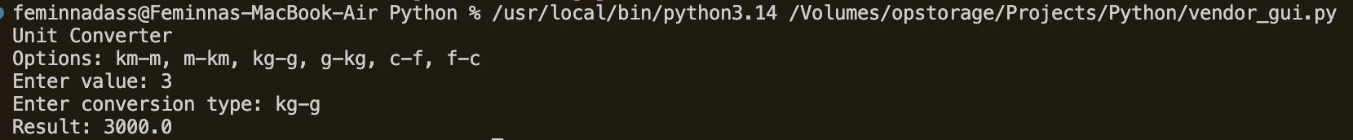
- GRAPHICAL USER INTERFACE

import tkinter as tk from tkinter import messagebox

def convert(): try:
value = float(entry.get()) unit
= option.get()

if unit == "km → m": result = value * 1000 elif unit == "m → km": result = value / 1000 elif unit == "kg → g": result = value * 1000 elif unit == "g → kg": result = value / 1000 elif unit == "°C → °F":
result = (value * 9/5) + 32 elif unit == "°F → °C": result = (value - 32) * 5/9
messagebox.showinfo("Result", f"{round(result,2)}")
except: messagebox.showerror("Error", "Enter valid number")

root = tk.Tk()
root.title("Unit Converter") root.geometry("300x200")

tk.Label(root, text="Enter Value").pack() entry = tk.Entry(root) entry.pack()

option = tk.StringVar() option.set("km → m")

tk.OptionMenu(root, option,
"km → m", "m → km",
"kg → g", "g → kg",
"°C → °F", "°F → °C").pack(pady=10)

tk
.
Button
(
root
,
text
=
"
Convert
",
command
=
convert
).
pack
()

root
.
mainloop
()

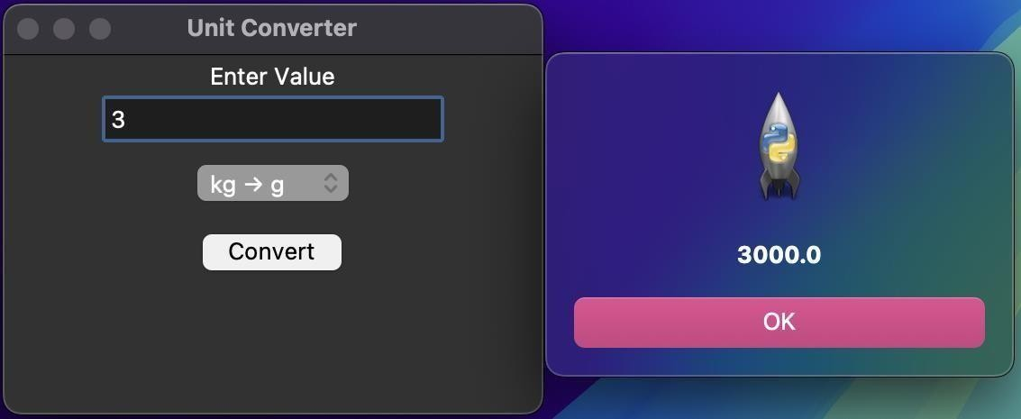
- VOICE USER INTERFACE

import speech_recognition as sr

def process(command): words = command.lower().split()

try: value = float([w for w in words if w.replace('.', '', 1).isdigit()][0])

if "kilometer" in words or "km" in words: print(value * 1000, "meters")

elif "meter" in words: print(value
/ 1000, "kilometers")

elif "kilogram" in words or "kg" in words: print(value * 1000, "grams")

elif "gram" in words: print(value
/ 1000, "kilograms")

elif "celsius" in words: print((value *
9/5) + 32, "fahrenheit")

elif "fahrenheit" in words:
print((value - 32) * 5/9, "celsius")
except: print("Could not understand command")  r = sr.Recognizer()  with sr.Microphone() as source:  print("Speak your conversion command...")  r.listen(source)  try:  text = r.recognize_google(audio) print("You said:", text) process(text) except:  print("Speech not recognized") | audio | =
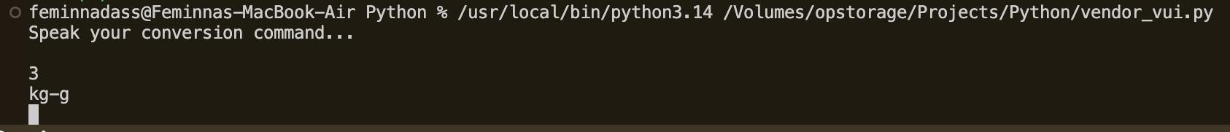
4. USER SATISFACTION COMPARISON:

